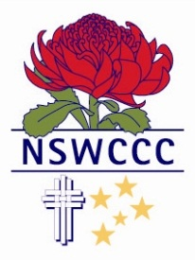

NSW COMBINED CATHOLIC COLLEGES SPORTS ASSOCIATION

KARINA BROWN
Blue Award
2015
Athletics
Mercy Catholic College Chatswood

Karina is a highly skilled athlete and exemplary student. She has represented her College and the Broken Bay Diocese in Athletics since her commencement at high school. As she has progressed through the years at Mercy College, she has concentrated her attention on the disciplines of high jump and hurdles.
Karina achieved two gold medals in the 17+ years hurdles and high jump at the 2015 New South Wales Combined Catholic Colleges Athletics Championships. She also achieved a gold medal in the 17+ high jump and a silver medal in the hurdles, at the NSW All Schools Championships.
Based on these fine achievements, Karina was selected into the NSW Schools Team to compete at the Australian Schools Athletics Championships.
In addition to her sporting prowess, Karina has been elected school captain for 2016. A position she strongly deserves due to her environmental work, contribution to school sport and dedication to her studies.
We wish Karina the best of luck in her future endeavours.

